Week 4 Exercise
Objective 1: Conceptual Foundation

Apache Spark is a widely used big data framework. At its core, spark enhances data processing. The driver (coordinator) is Spark Context. It plugs into different cluster managers such as yarn or Kubernetes. The manager decides how CPU and ram is assigned. Finally, the worker nodes run multiple tasks. The cumulative architecture is that driver coordinates, the manager distributes resources, and the executors run the tasks.
RDD is a fundamental concept to spark. RDD stands for resilient distributed dataset. Simply put, RDD allows spark to operate with redundancy to make the data fault tolerant. DAG executes your code across the structure. Spark itself WILL NOT execute until you call the execute command. This is ideal because it allows Spark to be “lazy” and formula a plan for the command across the cluster. A DAG is constructed which executes the code across the cluster. There is also in memory processing. This means that data is retained within memory, allowing spark to massively outperform MapReduce.
Past exercises used Hadoop map reduce. Compared to Spark, Map Reduce required reading/writing to disks whereas Spark did most of the work in memory. Spark’s memory utilization saves resources and speeds up performance. If it feels like Spark is doing things smarter, it’s because Hadoop/MapReduce are 1st generation computing whereas Spark is 2nd generation.

Objective 2 – Running SparkPi with PySpark
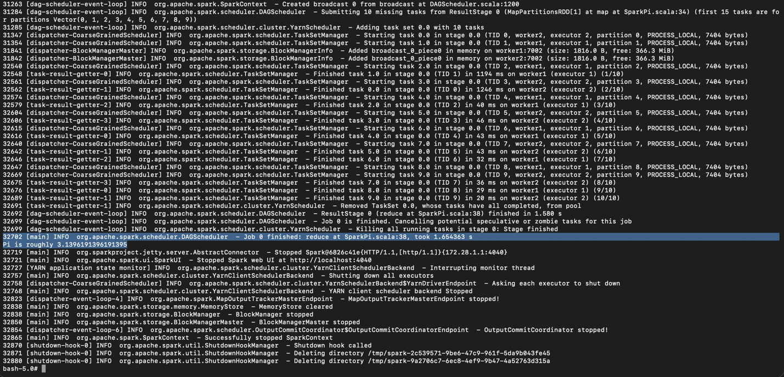

Objective 3 – Spark Scala Shell
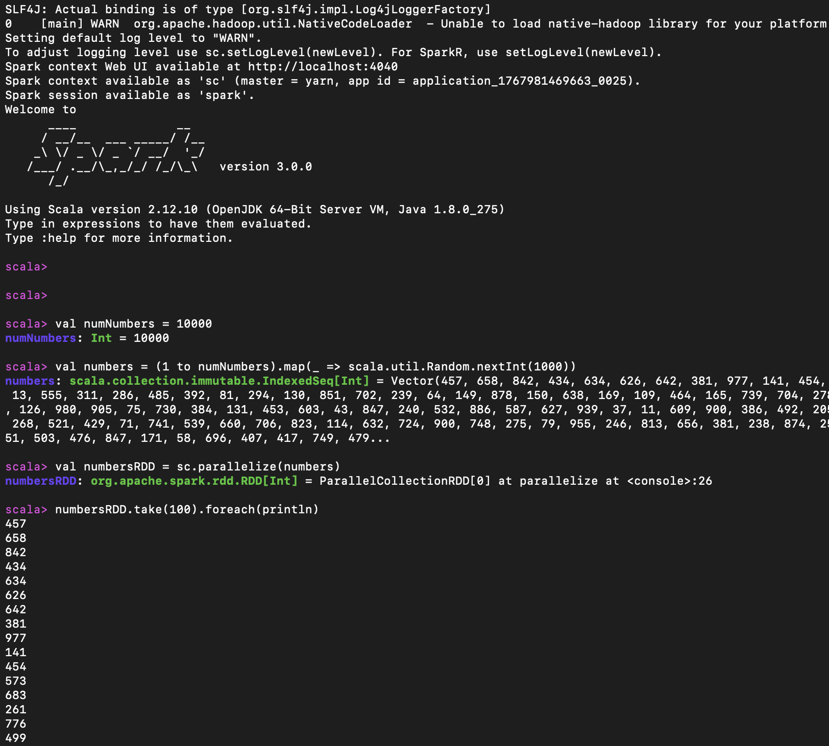

Objective 4 – Custom Transformation with Scala

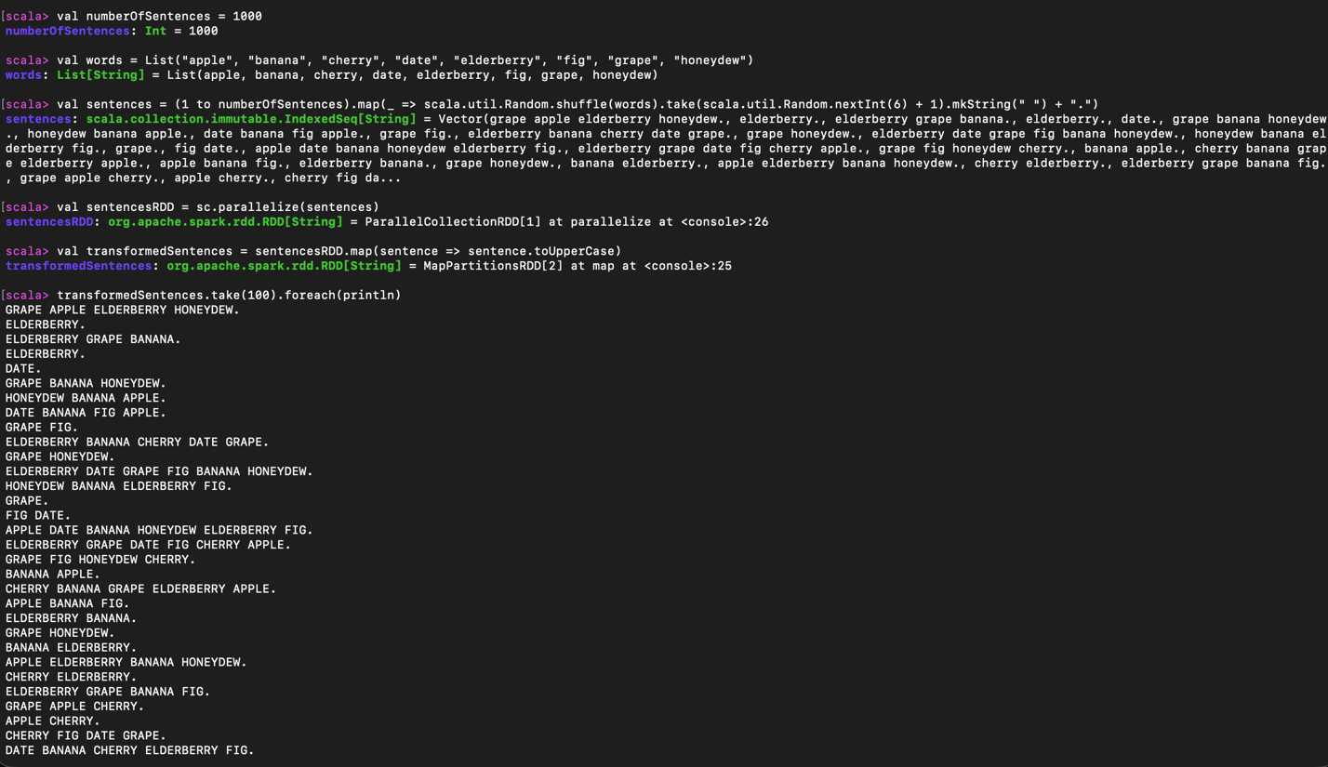

Objective 5 – Spark IDE + week4.py

